Name: P.Moshiya
Reg No:192572142
Course:Computer Vision
Code:ITA0502

Question 1: Real-World Scene Capture Pipeline
- Concept Hierarchy Framework
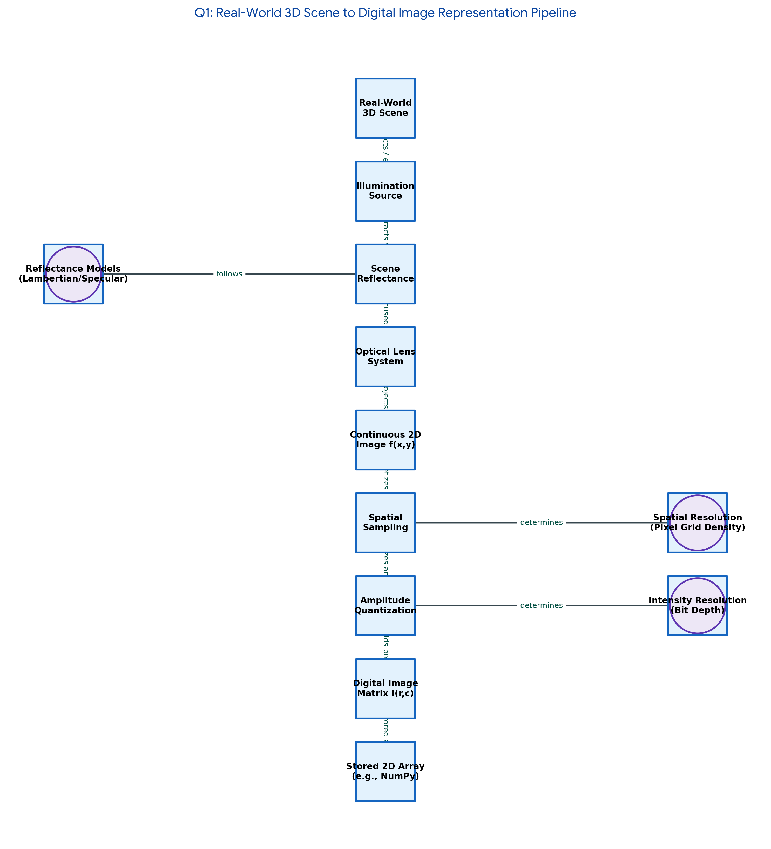
2. Relational Linkage Matrix Table
Source Node | Linking Phrase / Relationship | Target Node
Real-World 3D Scene | reflects light emitted from | Illumination Source
Real-World 3D Scene | projected onto focal plane via | Camera Optics System
Camera Optics System | governed geometrically by | Thin Lens Model
Thin Lens Model | maps 3D coordinates to | Continuous Image Plane
Continuous Image Plane | excites pixel sites across | Sensor Array (CCD/CMOS)
Sensor Array (CCD/CMOS) | converts photon flux into | Analog Electrical Signal
Analog Electrical Signal | discretized spatially by | Spatial Sampling
Analog Electrical Signal | discretized in amplitude by | Intensity Quantization
Spatial Sampling & Quantization | generates the discrete numerical | Digital Image Matrix I(x,y)

3. Literature Integration & Theoretical Validation
- Horn & Brooks (Radiational Physics Foundations): Formulates light radiance metrics converting to continuous image plane irradiance values.
- Gonzalez & Woods (Digital Signal Discretization): Validates coordinate bounds governing spatial discrete discrete mapping configurations.
- Szeliski (Computer Vision Geometric Principles): Structures geometric projection constraints leveraging homogeneous linear spatial transform equations.

Question 2: Visual Data Handling Pipeline Stages
- Concept Hierarchy Framework
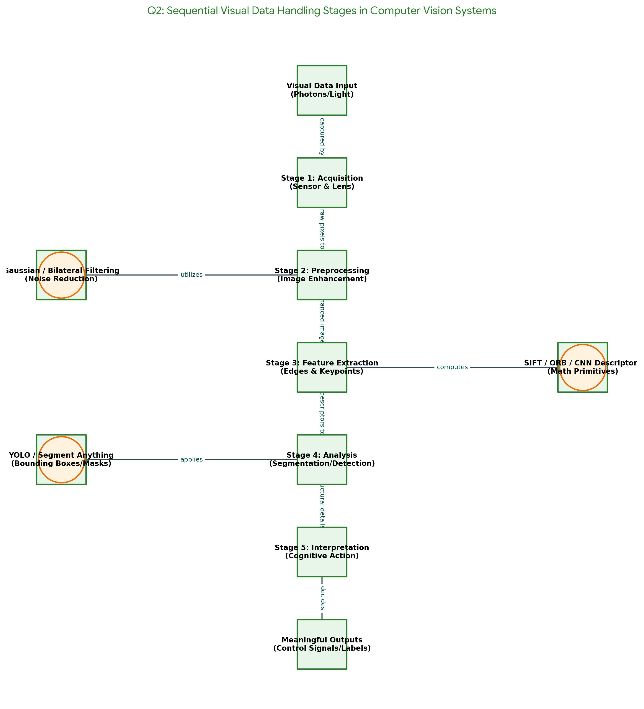
2. Relational Linkage Matrix Table
Source Node | Linking Phrase / Relationship | Target Node
Visual Data Handling Pipeline | initiates execution with | Data Acquisition
Data Acquisition | streams raw uncompressed frames to | Image Preprocessing
Image Preprocessing | improves Signal-to-Noise Ratio via | Noise Filtering (Gaussian/Median)
Image Preprocessing | rectifies illumination deviations via | Histogram Equalization
Image Preprocessing | delivers clear normalized matrices to | Feature Extraction
Feature Extraction | isolates invariant primitive landmarks | Edges, Corners & Descriptors (SIFT/HOG)
Feature Extraction | provides engineered input vectors to | Semantic Analysis
Semantic Analysis | executes high-level localization via | Object Detection & Classification
Semantic Analysis | feeds contextualized metadata into | Interpretation Stage
Interpretation Stage | outputs operational instructions for | Decision Output Systems

3. Literature Integration & Theoretical Validation
- Lowe (Scale-Invariant Structural Keypoints): Standardizes continuous spatial point mapping shifts into scale-invariant image vector points.
- Dalal & Triggs (Gradient Histogram Configurations): Proves edge gradient spatial tracking arrays increase human detection accuracy performance safely.
- LeCun, Bengio, & Hinton (Deep Feature Automations): Displaces classic pipeline stages with multi-layer automated convolutional representations.
Question 3: Image Resolution vs. Perceptual Quality
1. Concept Hierarchy Framework
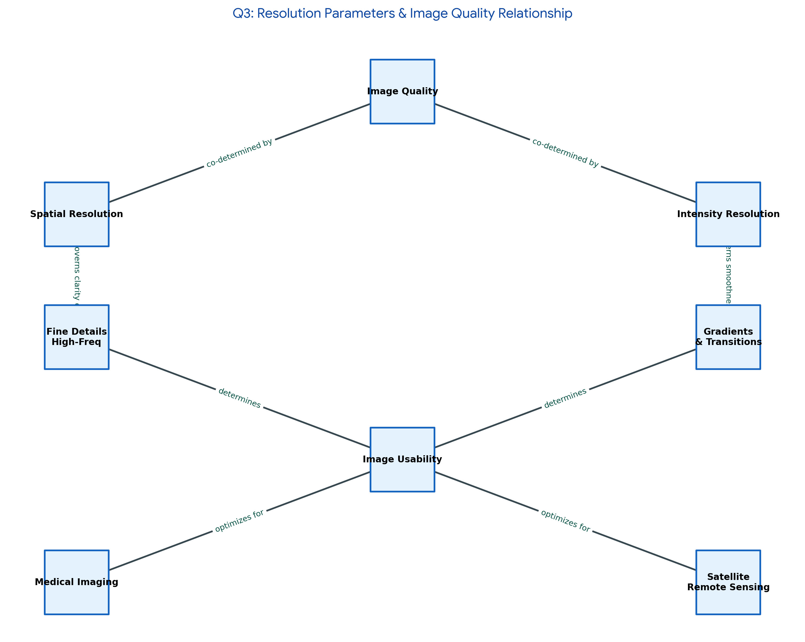
2. Relational Linkage Matrix Table
Source Node | Linking Phrase / Relationship | Target Node
Digital Image Quality | is structurally bounded by | Spatial Resolution
Digital Image Quality | is tonally bounded by | Intensity Resolution
Spatial Resolution | governed mathematically via | Sampling Frequency (Nyquist Limit)
Spatial Resolution | dictates minimum feature distance inside | Pixel Density (PPI/DPI)
Spatial Resolution | insufficient levels induce | Spatial Aliasing / Pixelation
Intensity Resolution | controlled by analog-to-digital | Quantization Bit Depth (k-bits)
Intensity Resolution | insufficient levels induce | False Contouring / Posterization
Spatial Aliasing & False Contouring | collectively degrade overall semantic | Image Usability
Image Usability | establishes performance diagnostic safety in | Medical Imaging (X-Ray/MRI)
Image Usability | bounds target categorization confidence inside | Satellite Remote Sensing

3. Literature Integration & Theoretical Validation
- Shannon (Nyquist-Shannon Uniform Sampling Law): Formulates boundary limitations required to neutralize disruptive spatial sampling frequencies.
- Wang et al. (Perceptual Structural Similarity Assessment - SSIM): Evaluates degradation errors through human perceptual index structures over pixel variance math.
Question 4: Environmental & Acquisition Sensor Conditions
1. Concept Hierarchy Framework
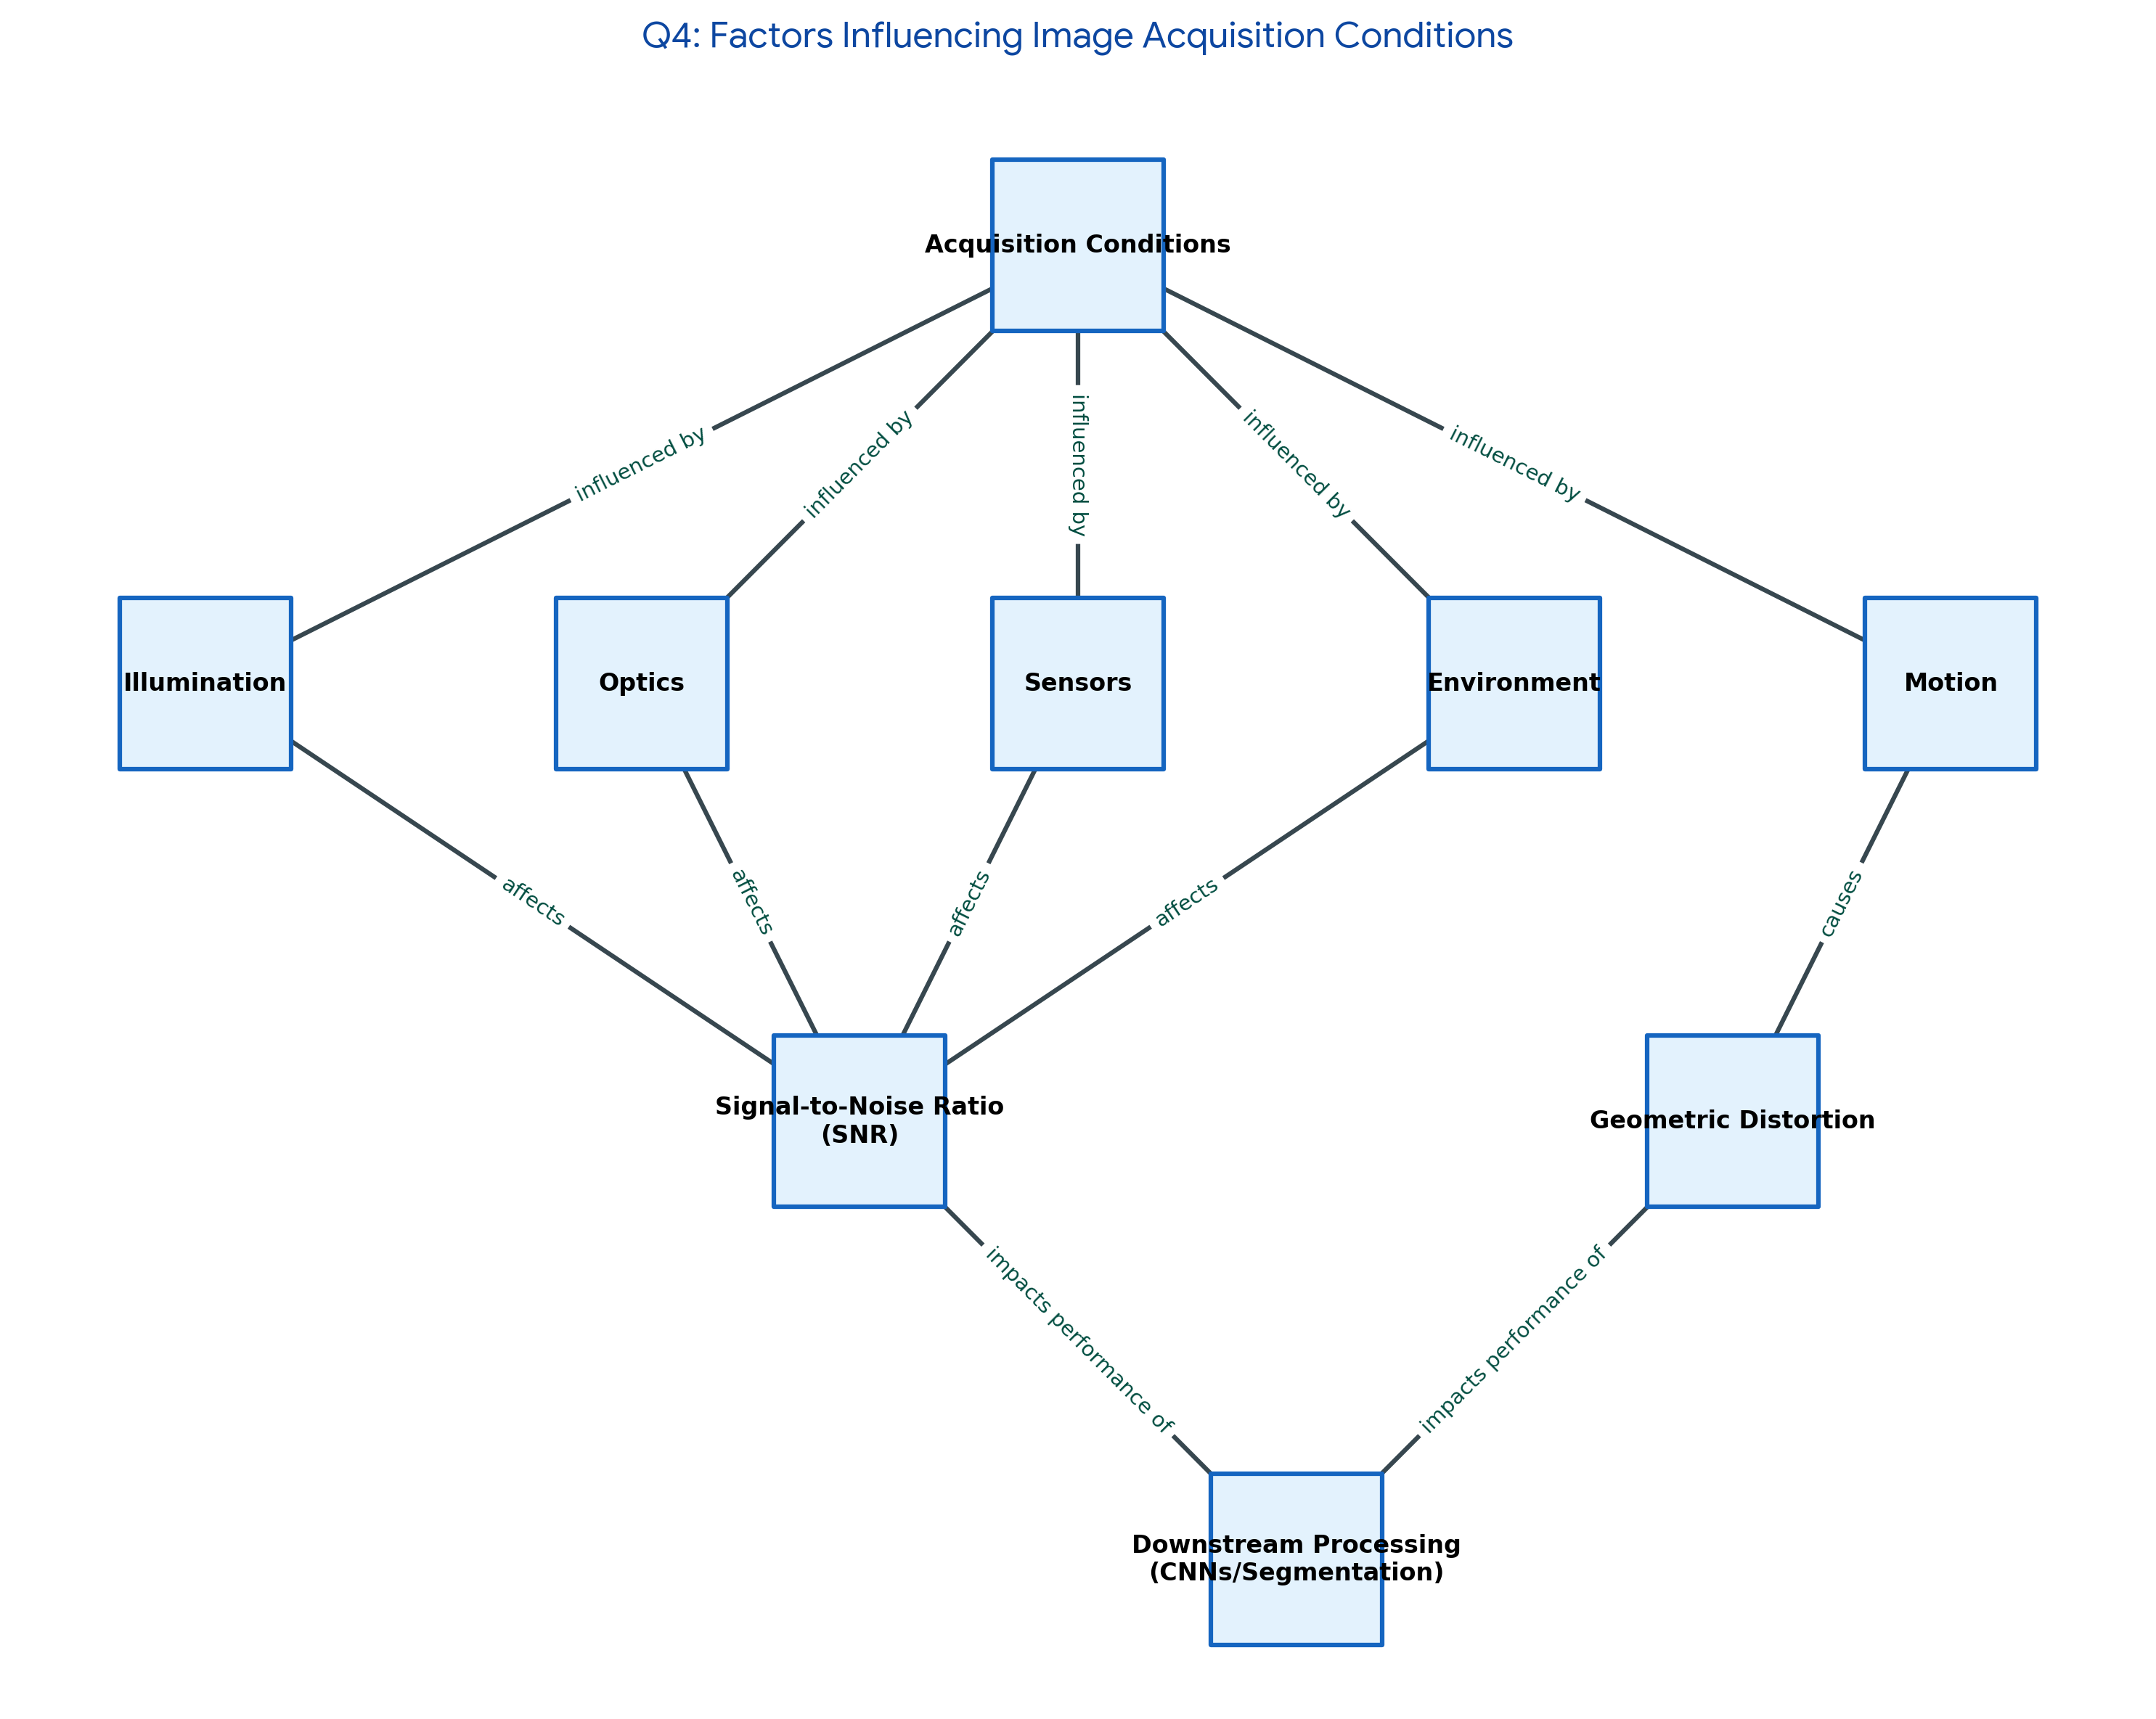
2. Relational Linkage Matrix Table
Source Node | Linking Phrase / Relationship | Target Node
Image Acquisition Conditions | highly sensitive to changes in | Ambient Illumination
Ambient Illumination | extreme variations cause severe | Saturation & Contrast Loss
Image Acquisition Conditions | distorted internally by electronic | Sensor Characteristics
Sensor Characteristics | heat and silicon variations produce | Thermal & Shot Noise
Image Acquisition Conditions | degraded temporally by ongoing | Relative Scene Motion
Relative Scene Motion | long exposures open to dynamics yield | Motion Blur Artifacts
Image Acquisition Conditions | scattered physically by the external | Environmental Medium
Environmental Medium | particulate interactions produce | Atmospheric Haze / Fog Occlusion
Saturation, Noise, Blur, & Haze | corrupt data tracking vectors inside | Downstream Pipeline Stages
Downstream Pipeline Stages | induces catastrophic matching failures in | Edge Catching & Feature Trackers

3. Literature Integration & Theoretical Validation
- Lucas & Kanade (Differential Tracking Constraints): Traces failure parameters when physical motion disrupts bright constancy assumptions.
- He, Sun, & Tang (Haze Removal Optimization Systems): Employs statistical scene priors to restore light attenuation loss caused by particulate interactions.
Question 5: System Capabilities vs. Target Verticals
1. Concept Hierarchy Framework
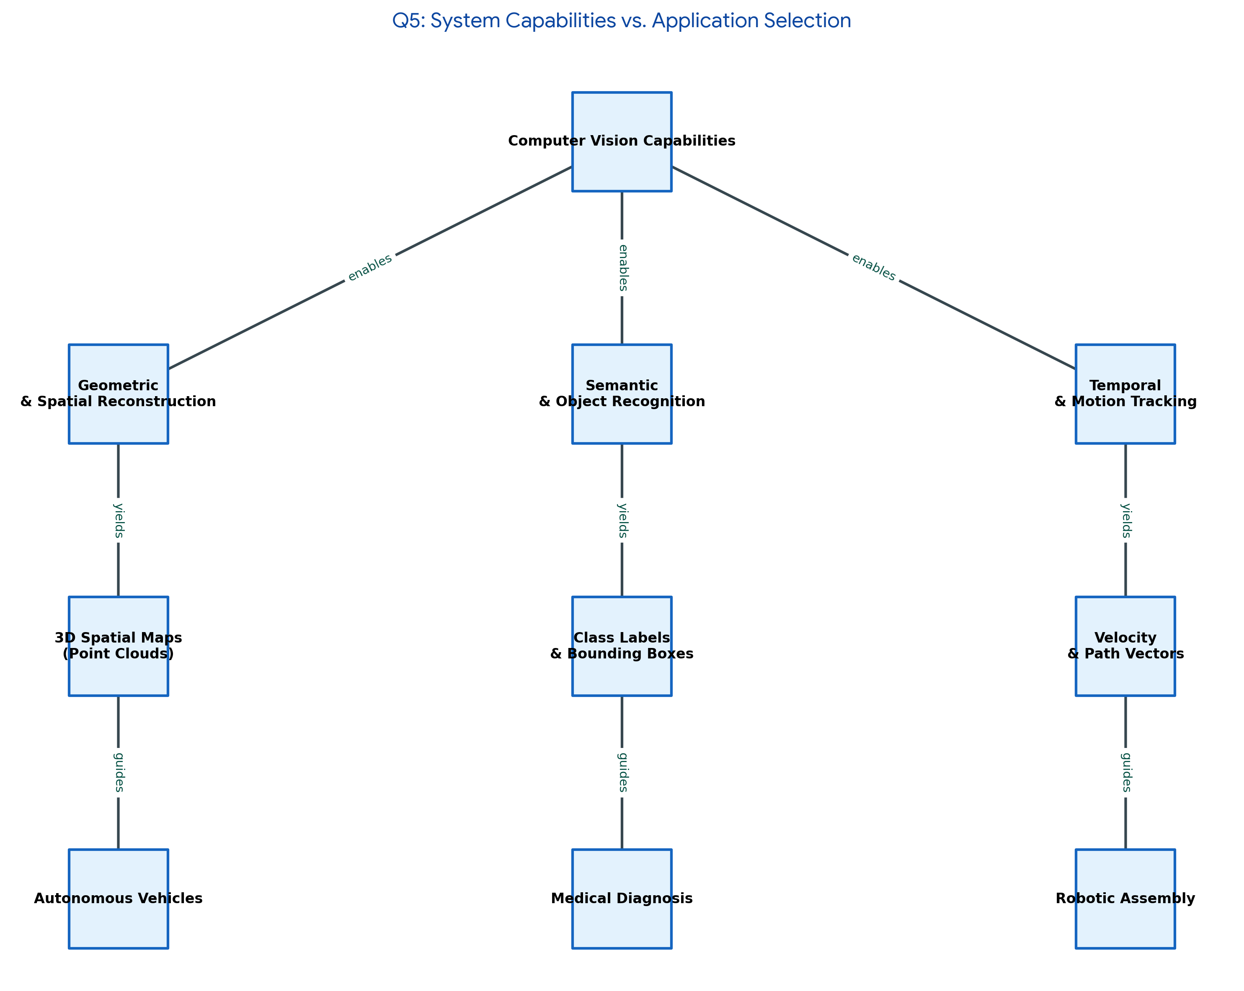
2. Relational Linkage Matrix Table
Source Node | Linking Phrase / Relationship | Target Node
CV System Architecture Planning | matches target needs to | Algorithmic Execution Capabilities
Algorithmic Execution Capabilities | provides depth extraction via | 3D Reconstruction & Stereopsis
3D Reconstruction & Stereopsis | enables spatial collision awareness in | Autonomous Vehicles
Algorithmic Execution Capabilities | provides continuous space tracking via | Temporal Object Tracking
Temporal Object Tracking | drives abnormal behavior detection for | Surveillance Infrastructure
Algorithmic Execution Capabilities | provides class boundaries through | Statistical Classification
Statistical Classification | identifies structural defects within | Industrial Metrology / Quality Control
CV System Architecture Planning | must adapt and optimize within | Operational & Computing Constraints
Operational & Computing Constraints | sets absolute hardware execution caps on | Edge Infrastructure (FLOPS/FPS)
Edge Infrastructure (FLOPS/FPS) | determines final production deployment safety in | Real-World Target Verticals

3. Literature Integration & Theoretical Validation
- Redmon et al. (Single-Stage High-Velocity Detection Maps): Charts the fundamental trade-off limitations connecting compute speed (FPS) directly to bounding box location accuracy.
- Hartley & Zisserman (Projective Solid Epipolar Layouts): Formulates rigid multi-view matrix math equations required to secure valid automated metrology measurements.

